An Experimental Approach to Multimodality
How Musical and Architectural Styles Interact in Aesthetic Perception
Martin Siefkes, University of Technology Chemnitz, & Emanuele Arielli, University IUAV Venice
Preprint version; please refer to the published version for citation*

Abstract: Intermodality (also called intersemiosis or crossmodality) is a growing topic of interest in psychology, linguistics, and aesthetics. In experimental aesthetics, the more specific question how judgments of stylistic and aesthetic qualities are influenced across perceptual modes has thus far gained little attention. However, intermodal interactions are of great interest, since a growing percentage of recently produced artefacts (multimedia artworks, films, online platforms, presentations etc.) are inherently multimodal. If experimental aesthetics wants to deal with current artistic production and the aesthetic dimension of contemporary culture, the theoretical background and methodology of investigating multimodal artefacts will have to be re-considered.
In this paper, we report the result of two studies that look at interactions between perceptual modes and aesthetic judgment of architecture and music. We examined how two musical styles influence the judgment of buildings belonging to the corresponding architectural styles. In the two studies, we found inconclusive results for the influence of background music. However, both studies demonstrated the effect of intermodal congruence or incongruence on the judgment of buildings: when the music was congruent with the architecture (e.g. baroque architecture and baroque music), the observed architectural style was judged as more balanced, more coherent, and in study II also as more complete.
Content
1. Introduction 2
1.1 The rise of multimodality 2
1.2 Intermodal interactions: an interdisciplinary perspective 2
1.3 Intermodal influences between styles 3
2. The studies 4
2.1 Hypotheses and predictions 4
2.2 Study I 6
2.2.1 Participants 6
2.2.2 Material 6
2.2.3 Design and procedure 8
2.2.4 Results and discussion 9
2.3 Study II 11
3.2.1 Study design 11
3.2.2 Results and discussion 11
2.4 General discussion 16
2.5 Conclusion 17
3. References 18

Introduction

The rise of multimodality
Multimodality is a rapidly growing field in linguistics and semiotics, and empirical research on interactions between modes forms an integral part of this field. However, research on the interplay of perceptual modes also has a long-standing history in cognitive psychology where it is often investigated with experimental methods. Both traditions come together in experimental aesthetics, an interdisciplinary research field dating back to the beginnings of modern psychology in the 19th century that has recently seen a revival (as witnessed, for example, by the founding of the Max Planck Institute for Empirical Aesthetics in Frankfurt am Main in 2013). Some differences in terminology exist and should be noted: whereas in linguistic multimodality research, the terms “intermodality” and “intersemiosis” are frequently used (cf. Wildfeuer 2012), psychological studies often speak of “crossmodal interactions” (cf., e.g., Vines et al. 2006).
In recent years, approaches to multimodal communication (cf., e.g., Kress/van Leeuwen 2001; O’Halloran/Smith 2011; Bateman/Wildfeuer 2014) have gained rapidly growing attention, sometimes with a specific focus on discourse analysis (cf., e.g., Siefkes/Schöps 2013; Machin 2014). Multimodality research has begun to investigate the interactions between text and image (cf. Hess-Lüttich/Wenz 2006; Bateman 2014), language and gesture (cf. Fricke 2012), and speech and images in film (cf. Bateman/Schmidt 2012; Wildfeuer 2014). This research lays the groundwork for a broader and more precise approach to multimodality and opens new research routes. It is based on analytical and formal approaches founded in structuralism and semiotics, as well as on corpus-linguistic methods; although it has brought important theoretical advances and thorough empirical analyses, this research has not, to our knowledge, resulted in experimental studies of intermodal effects.
This paper presents the results of two studies conducted at the University IUAV of Venice, which focused on the interactions between the aesthetic perception of architecture and background music in audiovisual presentations. We investigated how two musical styles (modern and baroque) influence the judgment of buildings belonging to the corresponding architectural styles. The two studies therefore connected two different types of artefacts, namely buildings and pieces of music, both of which have conventional meanings and can thus be regarded as semiotic modes, and are also perceived in different perceptual modes, namely visual and auditory perception. The results show that meanings connected with one mode, as measured by ratings on semantic scales, are influenced by another mode.

Intermodal interactions: an interdisciplinary perspective
What we call “intermodality” has been investigated in various disciplines and with different terminology. In cognitive psychology, the term “crossmodality” is used to describe mutual influences between sensorial channels such as auditory, visual or tactile perception, which have, in the last decades, become a thoroughly researched topic in perception studies (an overview of this research is given in Calvert et al. 2004). A much-discussed effect concerns the influence of auditory information on visual perception, and vice versa (cf. McGurk/MacDonald 1976). Research on crossmodal phenomena has typically been restricted to the perception of low-level information, such as in the case of vision to the perception of shape, colour, and movement. Recently, however, studies have begun to show the influence of perceptual information on higher-level cognitive processes (cf. Chapados/Levitin 2008; Davidson 1993; Vines et al. 2006).
Of particular interest is the question of correspondences between modes with regard to their unity and congruence. Semantic congruence usually refers to those situations in which pairs of stimuli from different modes are presented as matching. Studies of multisensory perception observe the consequences of presenting matching or mismatching object pictures and sounds (such as a tweeting sound paired with a picture of a dog; cf. Molholm et al. 2004) or of visually presenting letters with matching or mismatching speech sounds (cf., e.g., van Atteveldt et al. 2004). Synaesthetic congruence, on the other hand, refers to corresponding experience of stimuli that are reported by a majority of people, such as a high pitched sound corresponding to intense brightness or colour versus a low pitched sound corresponding to lower brightness or colour. It has been argued that stimuli that are either semantically or synaesthetically congruent will more likely be bound together, a notion that is referred to as the “unity effect” (cf., e.g., Spence 2007; Vatakis/Spence 2008).
In linguistics, a related discussion under the label “intermodality” began about a decade ago (cf. Marsh/White 2003; Martinec/Salway 2005). Siefkes (2015) proposes a formal approach that integrates intermodal interactions into Segmented Discourse Representation Theory (SDRT). Generally speaking, multimodal texts are usually assumed to presuppose not only the participation of different modes, but also some degree of intermodal integration; thus, in every multimodal text interpretation, intermodal effects play a certain role.

Intermodal influences between styles
In this article, we introduce a first approach to intermodal effects between matching and mismatching styles presented in different modes. Specifically, we assume that styles in different cultural areas that are designated with the same category name (e.g., “baroque” music and “baroque” architecture) have some features in common; when we regard music and architecture as semiotic modes, we can investigate the intermodal congruence and incongruence of styles as a special case of intermodality, which in turn is an important aspect of multimodality research. The methods presented in this paper, which are mostly from the area of experimental psychology, are therefore directly relevant for multimodality research, since they enable the experimental verification of hypotheses about how modes work together in multimodal texts.
Style is a principle of cognitive organisation that is used to recognise repeating patterns in artefacts and behaviour, independently of function, specific content, and context (cf. Siefkes 2012: 38-43; 2013: 4-5). When, for example, an architect designs buildings with different functions and sizes, under different conditions of location, terrain, contractual demands, and budget, we are still sometimes able to recognise the architect’s characteristic style. Styles can be defined across domains and have been described in many areas of culture and daily behaviour.
Though styles exist that are domain-specific, some styles can be defined as sets of general stylistic features that are applicable (sometimes with domain-specific adjustments) to different domains of culture such as music, architecture, art, and literature. Such styles can therefore be applied to establish intermodal congruence or incongruence. In the studies reported here, we take advantage of this aspect of style and use the domain-crossing styles “baroque music/architecture” and “modern music/architecture”.
In a pilot study planned and executed in 2012, we wanted to test the possibility that styles interact across perceptual modes. We investigated this specifically for the influence of musical style on the perception of architectural style and formulated the general hypothesis that music played inconspicuously in the background would influence judgments of architectural style. This pilot study was implemented at the University IUAV of Venice with students as participants. It confirmed the general hypothesis, but also pointed towards an even more interesting possibility: Some scales seemed to be applied involuntarily to the congruence/incongruence-relation between the modes themselves. The study hinted at the possibility that context factors as well as characteristics of participants might influence the results; therefore, we decided to conduct two studies with the same materials but different participant pools, one of them an online study.

The studies

Hypotheses and predictions
We wanted to test the interaction of baroque and modern architecture with baroque and modern music, in a 2×2 factorial design (for the factors background music and congruence/incongruence). In our studies, the semantic differential approach (cf. Osgood/Suci/Tannenbaum 1957) was used with the intention of measuring semantic values ascribed to styles. On the basis of previous work on style (cf. Siefkes 2011, 2012), which considers style as a multimodal phenomenon, we devised a list of semantic scales that we assumed might be relevant both for architectural and musical styles.
Based on previous research on the perception of architectural styles (e.g. Mastandrea et al. 2011) and the pilot study, we made the following predictions:
H1: Semantic scales measure stylistic differences: Different architectural styles are differently rated on some (adequately selected) semantic scales, which capture perceptual qualities and/or semantic associations that viewers connect with these styles.
We use the term “semantic scale” to refer to rating scales that are defined by a pair of bipolar adjectives such as high – low, or nouns such as reason – feeling. A “semantic differential” consists of a number of such scales, and viewers are asked to rate stimuli on these scales, allowing the researchers to determine if the stimulus in question is associated with one or the other of the polar terms, and how strong the associations are. The first hypothesis states that viewers of architecture are able to express some of the stylistic qualities they experience with the help of semantic scales.
H2: Stylistic cross-over effect: Music affects the stylistic judgment of architectural buildings on the basis of perceptual qualities and/or semantic associations connected with the musical style.
This hypothesis implies that viewers asked to judge architectural styles are not able to completely block out the stylistic qualities of music they hear. A sad musical piece, for instance, might transmit the quality ‘sadness’ to the evaluation of the architecture.
H3: Stylistic congruence effect: The stylistic congruence or incongruence between architectural and musical styles has a specific effect on some perceptual qualities or semantic associations of the architecture, resulting in an influence on certain rating scales which are suitable for measuring congruence or incongruence between styles.
Hypothesis H3 entails two separate, more specific hypotheses: (a) subjects have a unitary perception of the meaning of general stylistic categories such as “baroque” across perceptual modes (visual vs. auditory stimuli) as well as across semiotic modes (architecture vs. music); (b) subjects transfer the intermodal perception of congruity or incongruity to their ratings of architecture – in other words, they are not able to completely separate the intermodally experienced congruence or incongruence from the rating of a single mode.
The pilot study had indicated that the semantic scales balanced – unbalanced and incomplete – complete might be susceptible to the effect stated in H3. We additionally introduced a third rating scale which should also register the effect: coherent – incoherent. We postulated that these three scales are applicable to intermodal congruence or incongruence; if H3 is valid, the effect will show in these three scales. The other scales that we tested (see Section 2.2.3) were not supposed to be susceptible to this effect.
The two studies (I and II) were conducted in two completely different settings, in order to identify factors that could lead to results that are context specific. In the first study we made use of crowdsourcing as a method of online research (see below for details of the study design). Crowdsourcing can be defined as a job given to an undefined group of people in the form of an open call on the World Wide Web. Evaluations of crowdsourcing participant pools (cf. Buhrmester et al. 2011) have shown that subjects show a broader age range, higher average age, and more diverse socio-economic backgrounds than conventional subject pools at universities or research centres. The validity of scientific results garnered in crowdsourcing has repeatedly been demonstrated. Paolacci/Chandler/Ipeirotis (2010) replicated some classical cognitive experiments on reasoning and found out that results were identical to those from the laboratory experiments. Buhrmester et al. (2011) compared studies conducted on Mechanical Turk (one of the largest platforms for crowdsourcing) with respect to several psychometric scales and found no meaningful differences between the populations.

Study I

Participants
626 subjects participated in this study. All participants came from the USA, ranging over most states and a large number of different cities.

Material
The stimulus material used in this study consisted of four videos, each 25 seconds in length. Altogether, 10 pictures of buildings and two musical pieces were used (see Table 1).

Style |  | Stimulus | Building or  Musical piece  architect or  Composer | Image or video URL  Copyright holder  License  License URL
Baroque | A1 | 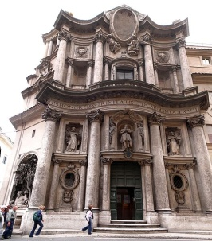 | San Carlo alle Quattro Fontane, Rome, Italy  Francesco Borromini | http://commons.wikimedia.org/wiki/File:SCarloQuattroFontaneRome2.jpg  © Welleschik  Creative Commons CC BY-SA 3.0  http://creativecommons.org/licenses/by-sa/3.0/
 | A2 | 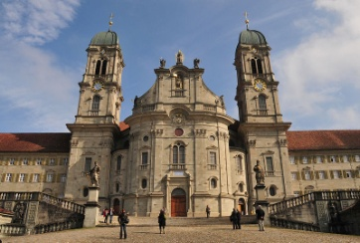 | Einsiedeln Abbey, Einsiedeln, Switzerland  Caspar Moosbrugger | http://commons.wikimedia.org/wiki/File:Kloster_Einsiedeln_Frontansicht.jpg  © Hofec  Creative Commons CC BY-SA 3.0  http://creativecommons.org/licenses/by-sa/3.0/
 | A3 | 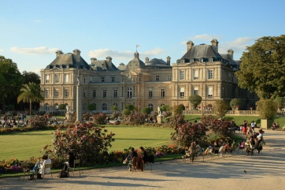 | Palais du Luxembourg, Paris, France  Salomon de Brosse, Alphonse de Gisors, et al. | http://commons.wikimedia.org/wiki/File:Palais_Luxembourg_Sunset_Edit.JPG  © Benh Lieu Song, modified by Sanchezn  Creative Commons CC BY-SA 3.0  http://creativecommons.org/licenses/by-sa/3.0/
 | A4 | 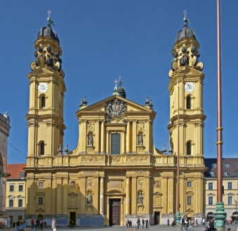 | Theatinerkirche, Munich, Germany  Agostino Barelli, Enrico Zuccalli | http://commons.wikimedia.org/wiki/File:MünchenTheatinerkirche_a.jpg  © Uwe Barghaan  Creative Commons CC BY-SA 2.5  http://creativecommons.org/licenses/by/3.0/
 | A5 | 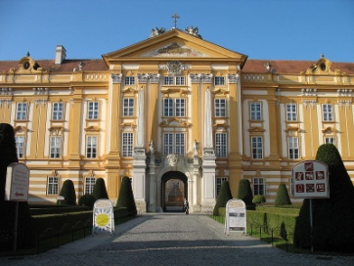 | Stift Melk, Melk, Austria  Jakob Prandtauer | http://de.wikipedia.org/wiki/Datei:Stift_Melk_001.jpg  © User:Fb78 (commons.wikimedia.org)  Creative Commons CC BY-SA 2.0 DE  http://creativecommons.org/licenses/by-nc-nd/2.0
 | M1 | Georg Philipp Telemann, Concerto grosso in D major, TWV 54:D3 (1716) | 1. Intrada – Grave  Trevor Pinnock / The English Concert  (0:00 to 1:12) | http://www.youtube.com/watch?v=uZ80V-YWEnc  © Deutsche Grammophon. All rights reserved
modern | A6 | 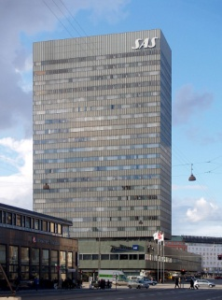 | SAS Royal Hotel, Copenhagen, Denmark  Arne Jacobsen | http://commons.wikimedia.org/wiki/File:SAS_Royal_Hotel,_Copenhagen,_1955-1960.jpg  © seier+seier  Creative Commons CC BY 2.0  http://creativecommons.org/licenses/by/2.0/
 | A7 | 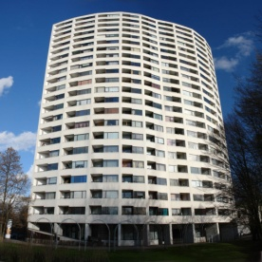 | Aalto-Hochhaus, Bremen, Germany  Alvar Aalto | http://commons.wikimedia.org/wiki/File:AaltoVahr-01.jpg  © Jürgen Howaldt  Creative Commons CC BY-SA 2.0 DE  http://creativecommons.org/licenses/by-sa/2.0/de/
 | A8 | 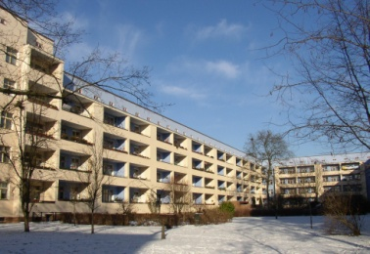 | Wohnstadt Carl Legien, Berlin, Germany  Bruno Taut | http://commons.wikimedia.org/wiki/File:Berlin_C_Legien_Trachtenbrodtstr_26.jpg  © Doris Antony  Creative Commons CC BY-SA 3.0  http://creativecommons.org/licenses/by-sa/3.0/
 | A9 | 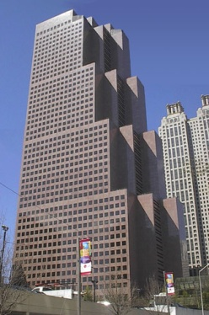 | Georgia Pacific Building, Atlanta, Georgia, USA  Skidmore, Owings & Merrill | http://commons.wikimedia.org/wiki/File:Georgia_pacific_building_atlanta_01.jpg  © Ashley Moore  Creative Commons CC BY-SA 3.0  http://creativecommons.org/licenses/by-sa/3.0/
 | A10 |  | Neue Nationalgalerie, Berlin, Germany  Ludwig Mies van der Rohe | http://commons.wikimedia.org/wiki/File:Neue_Nationalgalerie_Berlin.jpg  © Manfred Brückels  Creative Commons CC BY-SA 3.0  http://creativecommons.org/licenses/by-sa/3.0/
 | M2 | Soundtrack to the film Koyaanisqatsi | 03. Cloudscape  Philip Glass  (0:00 to 1:12) | http://www.youtube.com/watch?v=5SUpWrSVaIg  © Philip Glass. All rights reserved
Table 1: List of stimuli and sources used in both studies.

Four videos were created from these stimuli. Video 1 combined baroque architecture with baroque music (combining stimuli that were intermodally congruent in regard to style). Video 2 combined baroque architecture with modern music (intermodally incongruent). Video 3 combined modern architecture with baroque music (intermodally incongruent), and video 4 combined modern architecture with modern music (intermodally congruent).

Design and procedure
Subjects had to evaluate the style of the buildings shown in the videos, giving their general aesthetic preference, and rating them on different semantic scales describing expressive, stylistic and aesthetic qualities. The scales were presented as sliders which were movable by mouseclick (with numerical values from 0 to 101; sliders were preset to 50).
The first scale measured general aesthetic preference. Subjects were asked “Do you like the style of the buildings in the video?” The scale was labelled as follows:
not at all – very much

Subjects were then instructed: “Please judge the style on the following dimensions:”
introverted – extraverted
unbalanced – balanced
bright – dark
incoherent – coherent
grave – agitated
modest – bold
reason – feeling
complete – incomplete

Judgments (n = 626) were ordered and paid via Crowdflower.com; the study was hosted on the online study service Fluidsurveys.com. A validator was given at the end of the study, which had to be entered on the Crowdflower website. Incompletely filled-out surveys were not evaluated. The study logic was programmed to randomly assign participants, after a general instruction at the beginning of the study, to one of four conditions. In each condition, one of the four videos was shown. Instructions and all rating scales were given directly below the video. Videos were uploaded on YouTube and embedded in the survey; they did not run automatically, but were started by clicking on them (visualised by a large arrow as start symbol) and could be paused or navigated by the participant via a navigation bar under the video.
After submitting their answers by clicking “Next” at the bottom of the page, subjects were asked “Did you hear the background music?” (Yes/No) There was no “Back” button in the survey, and later editing of the results was disabled. 125 subjects that answered “No” were excluded from analysis. The 501 subjects that answered “Yes” took a mean of 01:31.3 (SD = 01:17.4) min for the study (measured by the Fluidsurveys website).

Results and discussion
For each of the nine sliders (aesthetic preference, introverted – extraverted, unbalanced – balanced, bright – dark, incoherent – coherent, grave – agitated, modest – bold, reason – feeling, complete – incomplete) as dependent variables, a 2×2 ANOVA was conducted with architecture and music as factors. The results are summarised in Table 2.

Dependent variables | Independent variables (Factors)
(Rating scales) | Architecture | Music | Architecture × Music
 | Levels: baroque / modern | Levels: baroque / modern | Levels: intermodally congruent / intermodally incongruent
aesthetic preference | baroque is preferred
introverted – extraverted | baroque is rated more towards extraverted
unbalanced – balanced | baroque is rated more towards balanced |  | architecture with music in the same style (= intermodally congruent) is rated more towards balanced
bright – dark | modern is rated more towards dark
incoherent – coherent | baroque is rated more towards coherent |  | architecture with music in the same style (= intermodally congruent) is rated more towards coherent
grave – agitated
modest – bold | baroque is judged more towards bold
reason – feeling | baroque is judged more towards feeling
complete – incomplete | modern is judged more towards incomplete
Table 2: Overview of significant effects in study I (α = 0.05).

For all dependent variables, a significant main effect (for α = 0.05) was found for the factor architecture, with the exception of grave – agitated. These results indicate that the subjects were able to meaningfully apply the given scales to the presented stimulus material, expect possibly for the scale grave – agitated. Either the participants were not able to apply this judgment scale to architecture, which might be explained with the fact that it is more often used in the context of music than of architecture. However, the possibility cannot be excluded that both styles were simply experienced as very similar on this scale. However, given the clear differences between the two styles on all other scales, the explanation that this scale was not successfully applied to the stimulus material seems more likely.
No main effect was found for the factor music.

(a) (b)
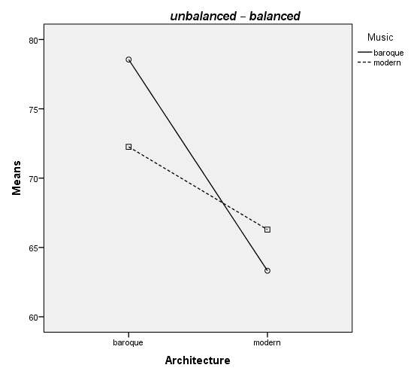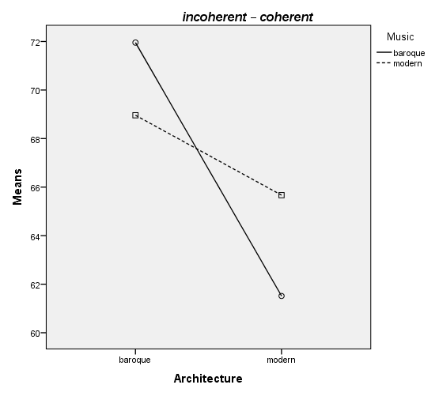

Fig. 1: Results of study I (selected).
(a) Mean value diagram for the semantic scale unbalanced – balanced in study I. Baroque architecture is judged as more balanced (F(1, 497) = 32.510, p = 0.000; baroque arch. M = 75.41, SD = 1.37, modern arch. M = 64.81, SD = 1.26). In the interaction effect architecture × music, architecture was judged as more balanced when it was accompanied by music in the same style (F(1, 497) = 6.208, p = 0.013; baroque arch./baroque music M = 78.55, SD = 1.81, baroque arch./modern music M = 72.26, SD = 2.05, modern arch./baroque music M = 63.32, SD = 1.83, modern arch./modern music M = 66.29, SD = 1.73).
(b) Mean value diagram for the semantic scale incoherent – coherent in study I. Baroque architecture was judged as more coherent (F(1, 497) = 14.935, p = 0.000; baroque arch. M = 70.46, SD = 1.31, modern arch. M = 63.59, SD = 1.20). In the interaction effect architecture × music, architecture was judged as more balanced when it was accompanied by music in the same style (F(1, 497) = 4.047, p = 0.045; baroque arch./baroque music M = 71.95, SD = 1.73, baroque arch./modern music M = 68.96, SD = 1.96, modern arch./baroque music M = 61.52, SD = 1.74, modern arch./modern music M = 65.67, SD = 1.66).

For the interaction architecture × music, effects were found for two of the nine ANOVAs. For the scale unbalanced – balanced as dependent variable, as well as the main effect for architecture, the interaction architecture × music was significant (cf. Fig. 1a).
For the scale incoherent – coherent as dependent variable, as well as the main effect for architecture, the interaction architecture × music was significant (cf. Fig. 1b).
On the basis of hypothesis H3, we would expect two results: firstly, that the three semantic scales unbalanced – balanced, incoherent – coherent and complete – incomplete would vary with the stylistic congruence or incongruence between modes. Secondly, that the direction of this effect would be as follows: for stylistic congruence (baroque stimuli in both modes, or modern stimuli in both modes), the judgments would deviate towards balanced, coherent, and complete. This effect was confirmed for two of the three scales (cf. Fig. 1). For complete – incomplete, although the means displayed differences in the expected directions, no significant effect was found.

Study II

Study design
The second study was conducted at the University IUAV of Venice. It used participants drawn from a subject pool available at the university. A total of 77 students from the degree programms in architecture and fashion design participated in the study. None reported any impairments in colour vision.
The semantic scales of study I were used again in study I, with the following technical differences: The participants used a 7-point Likert scale for rating, and they rated on paper, crossing one of seven boxes for the scale points.
The same four videos were used as in study I, but with one difference: each participant rated both architectural styles. Participants were thus assigned to one of two groups, which were tested separately: one group was shown both architectural styles with baroque music, the second both styles with modern music. It was explained that the videos were taken from the internet, but no mention of the music was made (it was assumed that this would make the music less conspicuous, since many user-created videos on internet video sites such as YouTube or Vimeo show sequences of images with musical background). In the instructions, participants were asked to look at the pictures and rate the architectural style of the buildings that were shown. The subjects could read the semantic scales before the presentation of the video. Each video was then shown twice to the participants.
Since each participant was shown two videos and judged both architectural styles, study II employed a mixed design with “architecture” as within-subjects factor and “music” as between-subjects factor. The within-subjects design has statistical advantages, since it allows the factoring out of individual differences by directly comparing the judgments each subject gives for both styles.

Results and discussion
In the two-factorial design, two factors and one interaction were tested for ratings on nine scales as dependent variables. Table 3 summarises the effects that were found in study II.
Dependent variables | Independent variables (Factors)
(Rating scales) | Architecture | Music | Architecture × Music
 | Levels: baroque / modern | Levels: baroque / modern | Levels: intermodally congruent / intermodally incongruent
aesthetic preference | modern is preferred
introverted – extraverted | baroque is rated more towards extraverted | baroque music influences ratings of architecture towards extraverted | architecture with music in the same style (= intermodally congruent) is rated more towards extraverted
unbalanced – balanced |  |  | architecture with music in the same style (= intermodally congruent) is rated more towards balanced
bright – dark | modern is rated more towards dark | modern music influences ratings of architecture towards dark
incoherent – coherent |  |  | architecture with music in the same style (= intermodally congruent) is rated more towards coherent
grave – agitated |  |  | architecture with music in the same style (= intermodally congruent) is rated more towards agitated
modest – bold | baroque is rated more towards bold |  | architecture with music in the same style (= intermodally congruent) is rated more towards bold
reason – feeling | baroque is rated more towards feeling
complete – incomplete |  |  | architecture with music in the same style (= intermodally congruent) is rated more towards complete
Table 3: Overview of significant effects in study II (α = 0.05).

It is noteworthy that four main effects for the factor “architecture” from the online study were confirmed in the second study: baroque architecture is judged to be more extraverted, modern architecture is judged as darker, bolder, and connected more with feeling. For the rating scale grave – agitated, neither the first nor the second study found a significant main effect.

(a) (b)
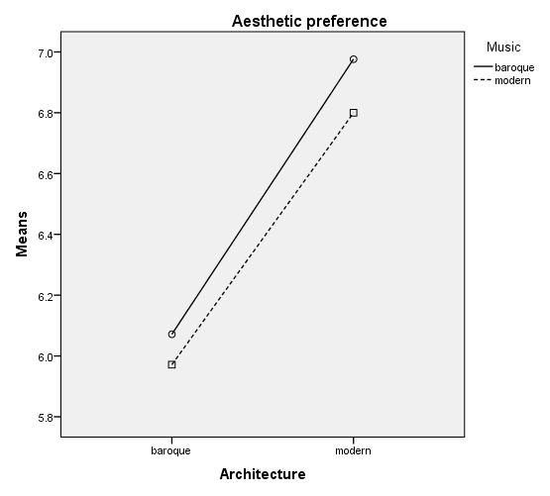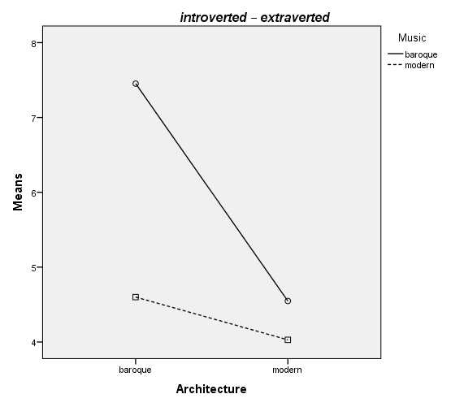
(c) (d)
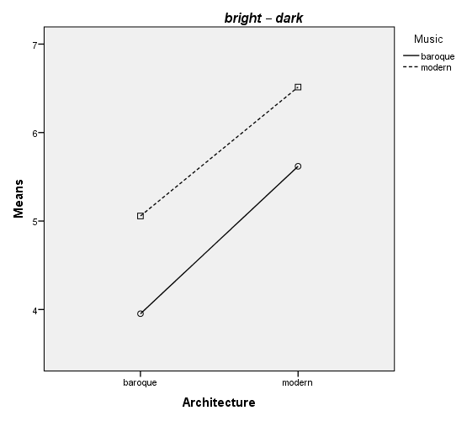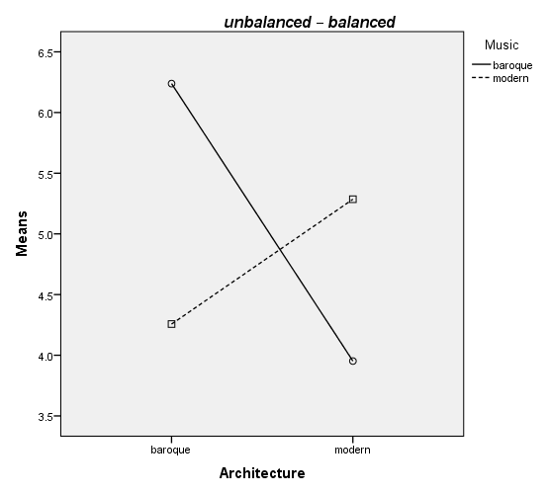
(e) (f)
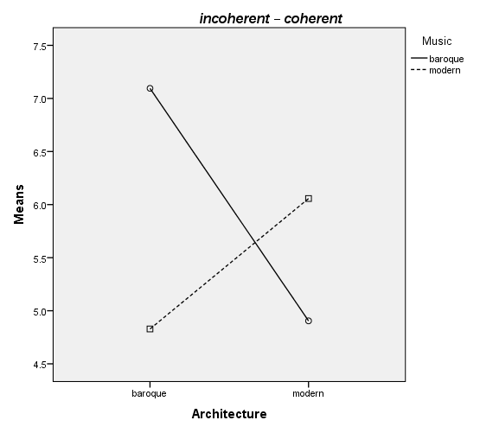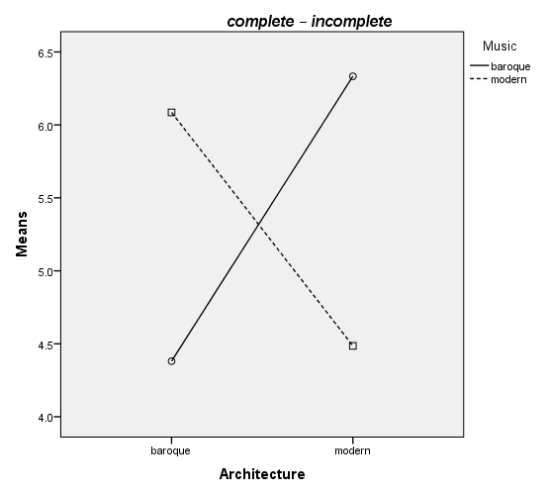

Fig. 2: Results of study II (selected).
(a) Mean value diagram for the rating scale Aesthetic preference in study II. Modern architecture was preferred (F(1, 75) = 4.930, p = 0.029; baroque arch. M = 6.03, SD = 2.05, modern arch. M = 6.90, SD = 2.36). To allow comparison with the other figures, the diagram shows the mean group values split for the factors Architecture and Music.
(b) Mean value diagram for the semantic scale introverted – extraverted in study II. For this scale, main effects for architecture and music were found, as well as an interaction effect. Baroque architecture was judged as more extraverted (F(1, 75) = 24.362, p = 0.000; baroque arch. M = 6.16, SD = 2.48, modern arch. M = 4.31, SD = 2.16). Architecture accompanied by baroque music was judged as more extraverted (F(1, 75) = 26.499, p = 0.000). In the interaction effect architecture × music, architecture was judged as more extraverted when it was accompanied by music in the same style (F(1, 75) = 10.977, p = 0.001; baroque arch./baroque music M = 7.45, SD = 1.99, baroque arch./modern music M = 4.60, SD = 2.10, modern arch./baroque music M = 4.55, SD = 2.33, modern arch./modern music M = 4.03, SD = 1.93).
(c) Mean value diagram for the semantic scale bright – dark in study II. Modern architecture was judged as darker (F(1, 75) = 18.932, p = 0.000; baroque arch. M = 4.45, SD = 1.93, modern arch. M = 6.03, SD = 2.37). Architecture accompanied by modern music was judged as darker (F(1, 75) = 9.500, p = 0.003).
(d) Mean value diagram for the semantic scale unbalanced – balanced in study II. In the interaction effect architecture × music, architecture was judged as more balanced when it was accompanied by music in the same style (F(1, 75) = 21.737, p = 0.000; baroque arch./baroque music M = 6.24, SD = 1.67, baroque arch./modern music M = 4.26, SD = 2.21, modern arch./baroque music M = 3.95, SD = 2.19, modern arch./modern music M = 5.29, SD = 2.94).
(e) Mean value diagram for the semantic scale incoherent – coherent in study II. In the interaction effect architecture × music, architecture was judged as more coherent when it was accompanied by music in the same style (F(1, 75) = 18.300, p = 0.000; baroque arch./baroque music M = 7.10, SD = 2.03, baroque arch./modern music M = 4.83, SD = 2.54, modern arch./baroque music M = 4.90, SD = 2.92, modern arch./modern music M = 6.06, SD = 2.31).
(f) Mean value diagram for the semantic scale complete – incomplete in study II. In the interaction effect architecture × music, architecture was judged as more complete when it was accompanied by music in the same style (F(1, 75) = 26.560, p = 0.000; baroque arch./baroque music M = 4.38, SD = 1.78, baroque arch./modern music M = 6.09, SD = 2.19, modern arch./baroque music M = 6.33, SD = 2.30, modern arch./modern music M = 4.49, SD = 2.57).

An interesting difference between the studies concerns general aesthetic preference: whereas the participants of the online study had preferred baroque architecture, the study subjects in the second study preferred modern architecture (cf. Fig. 2a). This difference might be explained by the fact that study II was conducted at a university of design and architecture. The students that participated in this study were not laypersons with regard to architecture; although some of them studied fashion design, they were probably influenced by a professional bias towards modern architecture.
Turning to intermodal influences, we found two main effects for “music”: baroque music influences judgments of the architecture it accompanies towards extraverted (Fig. 2b), and modern music influences judgments towards dark (Fig. 2c). Since the instructions clearly asked participants to judge the architecture, but did not mention the music, we call such effects “carry-over effects”: the music significantly influenced the judgment of the architecture on these two scales. These general carry-over effects indicate that qualities of the background music were inadvertently applied to judgments of the architectural style.
In addition, a second type of intermodal effect was found, where the relation between architectural and musical styles influenced the ratings of the architecture. In the chosen study design, effects such as these show up in the form of an interaction effect architecture × music, indicating that the two factors influenced each other. In study II, interaction effects were found for all three scales where they had been expected (see Section 2.1), namely for the scales unbalanced – balanced (Fig. 2d), incoherent – coherent (Fig. 2e), and complete – incomplete (Fig. 2f). For all three semantic scales, group means varied in the semantically plausible direction: in intermodally congruent presentations (i.e. where stimuli in both modes had the same style), the architecture was perceived as more balanced, more coherent, and more complete.
However, we should consider that three further interaction effects were found: architecture accompanied by music in the congruent style was also judged to be more extraverted, agitated, and bold. For the scale introverted – extraverted (cf. Fig. 4), we interpret this effect by positing that the carry-over effect (the main effect for “music”) applied only to the baroque music: the mean values for modern architecture are very close together, indicating that only baroque and not modern architecture was experienced as more extraverted with baroque music playing in the background.

Dependent variables | Independent variables (Factors)
(Rating scales) | Architecture | Music | Architecture × Music
 | Levels: baroque / modern | Levels: baroque / modern | Levels: intermodally congruent / intermodally incongruent
aesthetic preference
introverted – extraverted | baroque is rated more  towards extraverted
unbalanced – balanced |  |  | architecture with music in the same style (= intermodally congruent) is rated more towards balanced
bright – dark | modern is rated more  towards dark
incoherent – coherent |  |  | architecture with music in the same style (= intermodally congruent) is rated more towards coherent
grave – agitated
modest – bold | baroque is rated more  towards bold
reason – feeling | baroque is rated more  towards feeling
complete – incomplete
Table 4: Overview of significant effects found in both studies (α = 0.05).

Due to the different methods, study settings, and participant pools used in the two studies, we can regard the results found by both studies as well confirmed (see Table 4). However, we should not disregard entirely those results that are found only in one study: the distinct patterns in both studies indicate that the two study designs were variously sensitive for specific effects.
The high numbers of participants made study I especially sensitive, allowing relatively weak effects to become statistically significant. This higher sensitivity may explain why differences between the styles were found for all but one of the rating scales. The exception is the scale grave – agitated, which did not display significant differences in ratings in either study.
The second study demonstrated a higher sensitivity for all effects where the music influenced ratings of the architecture. Thus, only the second study found two carry-over effects, where musical qualities were attributed to the architecture that was to be rated. Furthermore, the second study found six stylistic congruence effects, only two of which were manifest in the first study. It is quite possible that the online study design alleviated the influence of the music. It could be speculated that some internet users have learnt to block out background music, or that some listened to it at a low volume.

General discussion
Four main effects for the factor “architecture” coincide in both studies: baroque architecture is judged more towards extraverted, bright, bold, and feeling, whereas modern architecture is connected with the opposing poles introverted, dark, modest, and reason. Thus, hypothesis H1 is confirmed: Semantic scales are able to capture at least some aspects of the experience of architectural style.
It can be concluded that even very broad architectural style concepts such as “modern” and “baroque”, which generalise over a wide range of buildings with different functions and architects, not to mention times and places of construction, are consistently connected with specific semantic scales. This is by no means obvious: it could be assumed that these style categories are too general to be correlated with specific perceptual qualities or semantic associations. Not all scales, however, were successfully applied to the two styles: the scale grave – agitated was probably unsuitable for judging the architectural styles, and for some of the other scales, only one study found an effect. On the basis of these results, we conjecture that a limited set of rating scales can be compiled that is consistently and non-randomly applied by subjects to a specific style.
The study did not investigate the nature of the connection between styles and semantic scales. It might be conjectured that some semantic scales capture certain perceptual qualities of the two styles, allowing the participants to express aspects of their experience in viewing the architecture. An alternative explanation would be that the styles in question are recognised as belonging to a category and the respective natural-language terms (e.g. “modern” or “baroque”, for English viewers) came to mind; the participants may then have rated the styles on the basis of semantic associations (connotations) of these terms.
The second hypothesis concerned “carry-over effects” between musical and architectural styles, proposing that qualities attributed to the music would influence the ratings of architecture asked of the participants. The results remain inconclusive: Whereas in study I, no semantic scale varied significantly with the background music, study II showed two effects: baroque music influenced the ratings of architecture towards extraverted, while modern music influenced the ratings towards dark. Further studies will be necessary to determine if some semantic scales consistently foster such carry-over effects.
The third hypothesis is confirmed by both studies: intermodal congruence or incongruence of styles influences the judgment of architecture for semantic scales such as unbalanced – balanced and incoherent – coherent and possibly for complete – incomplete (the second study did not confirm an effect for this last scale, but it was present in the pilot study). This points towards an important interaction effect between modes: for rating scales which are inherently applicable to intermodal relations between styles, the experience of stylistic congruence or incongruence ‘imposes’ itself onto aesthetic perception and judgment. This is an important result. Participants in both studies were explicitly asked to concentrate on and evaluate the style of the buildings they were shown, but they involuntarily adapted their ratings on these scales to the stylistic relation between the music and architecture they experienced. Theories of perception assuming the modularity of sensory processing, which have long dominated in psychology (cf. Fodor 1983, for a recent discussion see Deroy 2014), have recently been amended to incorporate multisensory processes (cf. Calvert et al. 2004) and these should include intermodal congruence effects as well. Similarly, research on intermodality in linguistics and semiotics should consider such effects, and focus more often on experimental studies that can help formulate and verify the principles of intermodal interaction.

Conclusion
For multimodality research, it is of central importance to understand how semiotic modes work together in multimodal texts. However, although a number of approaches for describing and annotating relations between modes have been developed (cf. Schriver 1997; Marsh/White 2003; Martinec/Salway 2005; Baldry/Thibault 2006; Liu/O’Halloran 2009; O’Halloran/Smith 2011; Bateman 2011, 2014), the mechanisms that underlie interactions between semiotic modes are still insufficiently explained.
In practice, multimodal analyses often approach discourse either by concentrating on the separate semiotic modes, or by assuming that meaning is produced by all modes together, licensing researchers to draw on each mode at will when explaining the overall meaning. However, apart from mode-specific contributions and holistically produced meanings, specific interactions between semiotic modes, where the presence of one mode has a definable influence on the formal, semantic, and/or stylistic properties of another mode, play a significant role in the creation of multimodal meaning. It is thus important to understand which types of interactions can be assumed (cf. Oviatt 1999) and to integrate them into a general model of text/discourse analysis that adequately represents all participating modes and textual levels.
The methods presented in this paper allow the measurement and comparison of meanings connected with semiotic artefacts that belong to different semiotic and/or perceptual modes. It was demonstrated how intermodal influences can be detected as rating differences on semantic scales, and how statistical methods are used to verify that these differences are caused by aspects of the other mode, or relations between the modes such as congruence or incongruence, and not by confounding factors. Other combinations of modes, and other aspects apart from stylistic qualities, can be investigated with the methods detailed in this paper; we therefore propose that the used methods can be regarded as an experimental approach to multimodality.

References
Baldry, Anthony/Thibault, Paul (2006): Multimodal Transcription and Text Analysis. London: Equinox.
Bateman, John A. (2011): “The Decomposability of Semiotic Modes”. In: O’Halloran, Kay/Smith, Bradley A. (eds.) (2011): Multimodal Studies. Exploring Issues and Domains. London: Routledge, pp. 17–38.
Bateman, John A. (2014): Text and Image. A Critical Introduction to the Visual-Verbal Divide. New York: Routledge.
Bateman, John A./Schmidt, Karl-Heinrich (2012): Multimodal Film Analysis. How Films Mean. London: Routledge.
Bateman, John A./Wildfeuer, Janina (2014): “A Multimodal Discourse Theory of Visual Narrative”. Journal of Pragmatics 74, pp. 180–208.
Buhrmester, Michael/Kwang, Tracy/Gosling, Samuel D. (2011): “Amazon's Mechanical Turk: A New Source of Inexpensive, yet High-Quality, Data?” Perspectives on Psychological Science 6(1), pp. 3–5.
Calvert, Gemma A./Spence, Charles/Stein, Barry E. (2004): The Handbook of Multisensory Processes. Cambridge, MA: MIT Press.
Chapados, Catherine/Levitin, Daniel J. (2008): “Cross-Modal Interactions in the Experience of Musical Performances. Physiological Correlates”. Cognition 108, pp. 639–651.
Davidson, Jane W. (1993): “Visual Perception of Performance Manner in the Movements of Solo Musicians”. Psychology of Music 21, pp. 103–113.
Deroy, Ophelia (2014): “Modularity of Perception”. In Matthen, Mohan (ed.): The Oxford Handbook of Philosophy of Perception. Oxford: Oxford University Press. DOI: 10.1093/oxfordhb/9780199600472.013.028
Fodor, Jerry A. (1983): Modularity of Mind. An Essay on Faculty Psychology. Cambridge, MA: MIT Press.
Fricke, Ellen (2012): Grammatik multimodal. Wie Wörter und Gesten zusammenwirken. Berlin/New York: de Gruyter.
Hess-Lüttich, Ernest W.B./Wenz, Karin (eds.) (2006): Stile des Intermedialen. Zur Semiotik des Übergangs. (= Kodikas/Code. Ars Semeiotica, 29, 1–3). Tübingen: Narr.
Kress, Gunther/van Leeuwen, Theo (2011): Multimodal Discourse. The Modes and Media of Contemporary Communication. London: Arnold.
Liu, Yu/O’Halloran, Kay (2009): “Intersemiotic Texture. Analysing Cohesive Devices between Language and Images”. Social Semiotics 19(4), pp. 367–388.
Machin, David (ed.) (2014): Visual Communication. Handbooks of Communication Science 4. Berlin: de Gruyter.
Marsh, Emily E./White, Marilyn D. (2003): “A Taxonomy of Relationships between Images and Text”, Journal of Documentation 59(6), pp. 647–672.
Martinec, Radan/Salway, Andrew (2005): “A System for Image-Text Relations in New (and Old) Media”, Visual Communication 4(3), pp. 339–374.
Mastandrea, Stefano/Bartoli, Gabriella/Carrus, Giuseppe (2011): “The Automatic Aesthetic Evaluation of Different Art and Architectural Styles”. Psychology of Aesthetics, Creativity, and the Arts 5(2), pp. 126–134.
McGurk, Harry/MacDonald, John (1976): “Hearing Lips and Seeing Voices”. Nature 264, pp. 746-748.
Molholm, Sophie/Ritter, Walter/Javitt, Daniel C./Foxe, John J. (2004): “Multisensory Visual-Auditory Object Recognition in Humans. A High-Density Electrical Mapping Study”. Cerebral Cortex 14, pp. 452–465.
O’Halloran, Kay/Smith, Bradley A. (eds.) (2011): Multimodal Studies. Exploring Issues and Domains. London: Routledge.
Osgood, Charles E./Suci, George J./Tannenbaum, Percy H. (1957): The Measurement of Meaning. Urbana: University of Illinois Press.
Oviatt, Sharon L. (1999): “Ten myths of multimodal interaction”. Communications of the ACM 42 (11), 74–81.
Paolacci, Gabriele/Chandler, Jesse/Ipeirotis, Panagiotis G. (2010): “Running Experiments on Amazon Mechanical Turk”, Judgment and Decision Making 5, pp. 411–419.
Schriver, Karen A. (1997): Dynamics in Document Design: Creating Texts for Readers. New York: Wiley.
Siefkes, Martin (2011): “Style: A New Semiotic View on an Old Problem”. Kodikas/Code. Ars Semeiotica, 34(1-2), pp. 15–25.
Siefkes, Martin (2012): Stil als Zeichenprozess. Wie Variation bei Verhalten, Artefakten und Texten Information erzeugt. Würzburg: Königshausen & Neumann.
Siefkes, Martin (2013): “Stil und Gesellschaft. Plädoyer für eine Allgemeine Stilistik”. Research report, University IUAV of Venice. Online: http://siefkes.de/dokumente/Siefkes_Stil_und_Gesellschaft.pdf [last accessed: 01 July 2015].
Siefkes, Martin (2015), “How Semiotic Modes Work Together in Multimodal Texts: Defining and Representing Intermodal Relations”. Online: 10plus1 – Living Linguistics 1, 2015: 113-131. 10plus1journal.com/issues/issue-1-media-linguistics/defining-and-presenting-intermodal-relations [last accessed: 20 September 2015].
Siefkes, Martin/Schöps, Doris (2013 [2014]): Neue Methoden der Diskursanalyse. Special issue, Zeitschrift für Semiotik 34(1–2).
Spence, Charles (2007): “Audiovisual Multisensory Integration”. Acoustical Science and Technology 28, pp. 61–70.
van Atteveldt, Nienke/Formisano, Elia/Goebel, Rainer/Blomert, Leo (2004): “Integration of Letters and Speech Sounds in the Human Brain”. Neuron 43, pp. 271–282.
Vatakis, Argiro/Spence, Charles (2008): “Evaluating the Influence of the Unity Assumption on the Temporal Perception of Realistic Audiovisual Stimuli”. Acta Psychologica 127, pp. 12–23.
Vines, Bradley W./Krumhansl, Carol L./Wanderley, Marcelo M./Levitin, Daniel J. (2006): “Cross-modal Interactions in the Perception of Musical Performance”. Cognition, 101(1), pp. 80–103.
Wildfeuer, Janina (2012): “Intersemiosis in Film: Towards a New Organisation of Semiotic Resources in Multimodal Filmic Text”. Multimodal Communication 1(3), pp. 276–304.
Wildfeuer, Janina (2014): Film Discourse Interpretation. Towards a New Paradigm for Multimodal Film Analysis. London/New York: Routledge.

* Siefkes, Martin & Arielli, Emanuele (2015), “An Experimental Approach to Multimodality: How Musical and Architectural Styles Interact in Aesthetic Perception”, in: Wildfeuer, Janina (ed.), Building Bridges for Multimodal Research. Bern/New York: Peter Lang, 247-265.
This special issue includes four articles on multimodal text and discourse analysis in various modes and media.
See the explanation of epochal styles in Siefkes 2012: 415-419.
Cf. Siefkes 2012 for an integrative approach to style in different domains; an introduction is given in Siefkes 2013.
By using crowdsourcing, we could target English native speakers for our study; furthermore, we could reach a more diverse population (especially regarding socio-economic background) in a different country (USA). Our job was evaluated, on a scale from 1 to 5 (where five was best), with an overall rating of 4.1; ratings were optional and given by c. 50% of participants.

